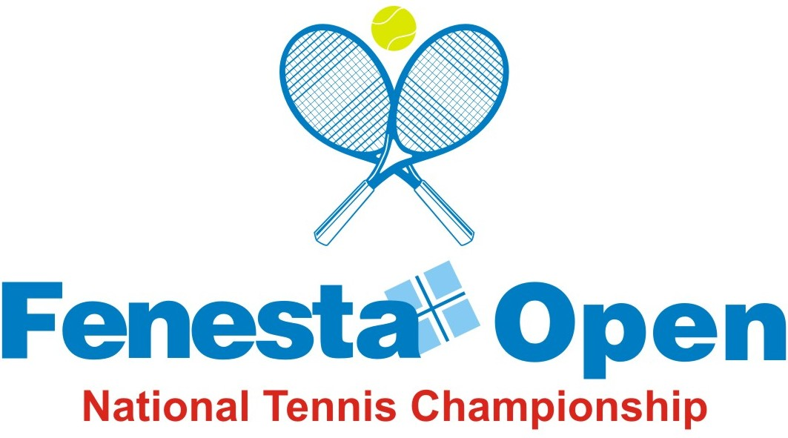

NAME OF THE TOURNAMENT | FENESTA OPEN NATIONAL TENNIS CHAMPIONSHIP-2013
NAME OF THE STATE ASSOCIATION | DELHI LAWN TENNIS ASSOCIATION
HONY. SECRETARY OF ASSOCIATION | MR V K BATRA
ADDRESS OF ASSOCIATION | DELHI LAWN TENNIS ASSOCIATION
DLTA COMPLEX, R K KHANNA TENNIS STADIUM,
No. 1, AFRICA AVENUE, NEW DELHI-110 029
TOURNAMENT WEEK | 14 OCTOBER 2013

THE ENTRY IS TO BE SENT |  | Wg Cdr P F MONTES (Retd)
ADDRESS |  | FENESTA NATIONAL TENNIS CHAMPIONSHIP-2013  ALL INDIA TENNIS ASSOCIATON  DLTA COMPLEX, R K KHANNA TENNIS STADIUM,  No. 1, AFRICA AVENUE,  NEW DELHI-110 029
TEL | 011-26176276, 26176280/1/3/4/5 |  | EMAIL | entries@aitatennis.com

NAME OF THE VENUE |  | R K KHANNA TENNIS STADIUM
ADDRESS OF VENUE |  | DLTA COMPLEX, No. 1, AFRICA AVENUE,  NEW DELHI-110 029
TELEPHONE | 011-26193955 |  | FAX | 011-26173159
COURT SURFACE | SYNTHETIC |  | BALLS | BABOLAT Roland Garros All Court
NO. OF COURTS |  |  | FLOODLIT

EVENTS & SIZE OF DRAW

EVENTS | QUALIFYING ROUNDS |  |  |  |  | MAIN DRAW
 |  | DA | WC | TOTAL | SEEDS |  | DA | WC | Q | TOTAL | SEEDS
Men & Ladies (Singles) |  | 56 | 8 | 64 | 16 |  | 20 | 4 | 8 | 32 | 8
Men & Ladies (Doubles) |  | 0 | 0 | 0 | 0 |  | 13 | 3 |  | 16 | 4
Boys U-18 (Singles) |  | 56 | 8 | 64 | 16 |  | 48 | 8 | 8 | 64 | 16
Girls U-18 (Singles) |  | 26 | 6 | 32 | 16 |  | 34 | 6 | 8 | 48 | 16
Boys & Girls U-18 (Doubles) |  | 0 | 0 | 0 | 0 |  | 14 | 2 |  | 16 | 4

EVENTS | ENTRY DEADLINE | WITHDRAWAL DEADLINE
Men, Ladies, Boys & Girls U-18 | 23 Sep 2013 | 07 Oct 2013

DATES - SIGN-IN & MATCHES
EVENTS | SIGN-IN |  | MATCHES
 | QUALIFYING | MAIN DRAW | QUALIFYING | MAIN DRAW
Men & Ladies Singles | Friday, 11 Oct 2013 ( 12-2 PM) | Sunday, 13 Oct 2013 ( 12 - 2 PM) | 12 & 13 Oct 2013 | 14 – 19 Oct 2013
Men & Ladies Doubles |  | Monday, 14 Oct 2013 ( Before Noon) |  | 14 – 19 Oct 2013
Boys & Girls U-18 Singles | No Sign-in* | No Sign-in* | 12 & 13 Oct 2013 | 14 – 19 Oct 2013
Boys & Girls U-18 Doubles |  | Sunday, 13 Oct 2013 ( 12 - 2 PM) |  | 14 – 19 Oct 2013

*As per revised rules of AITA at www.aitatennis.com wef 01 Oct 2012; No sign-in for juniors’ singles will be in place for all AITA tournaments.
Alternates will sign in on Saturday an hour before the start of the qualifying.
All players must show their valid ITN Registration card and pay the entry fees before playing their first match.
The referee must make the Draw Sheet & Order of play and have it displayed on the notice board by 1600 Hrs on Friday for the qualifying and 1800 Hrs on Sunday for the Main Draw.
PRIZE MONEY & DAILY ALLOWANCE
Men & Ladies | Rs. 9,29,800/-
Boys & Girls U-18 | Rs. 1,000/- per day as per AITA Rules

ENTRY FEE | SINGLES | DOUBLES
Men & Ladies | Rs. 750/-*
Boys & Girls U-18 | Rs. 800/- | Rs. 1,000/- per pair
*Rs. 750/- is for singles or doubles or both
HOTEL DETAILS
NAME | R K KHANNA TENNIS STADIUM
ADDRESS | DLTA Complex, No. 1 Africa Avenue, New Delhi-110 029
TEL | 011-26176280 / 1 / 3 / 4 / 5
Single | Rs. 2,500/- plus taxes
Double | Rs. 3,000/- plus taxes
Contact Persons | Mr Rachna Puri – (Mob – 09810385488)  Mr Ajeet Gandhi – (Mob- 08800547515)
E-mail | dlta@dlta.in, rachnapuri2003@gmail.com

One player can play maximum of two singles and one doubles (Main Draw or Qualifying) in the week.
- Boys & Girls who are born after 31 Dec 1998 are not permitted to play in Men and Ladies Events.

- Players born after 1st Jan 1995 and before 31 Dec 2000 are eligible for participation in U/18.

- Please send your entry by e-mail to entries@aitatennis.com. A confirmation that your entry has been received will be sent by return mail. It is the player’s responsibility to confirm receipt of their entries by AITA.

- AITA rules, regulations and code of conduct will be strictly enforced. Break of code, late withdrawals, no-show cases shall be reported to AITA for fines and suspension points.

- Any change/addition in rules etc. by the AITA shall be incorporated if advised to do so by AITA.

- It is mandatory for the player to carry ORIGINAL VALID ITN REGISTRATION CARD for the sign-in. In case the player registration is in process with AITA, In that case player has to carry Original receipt or copy of mail from AITA confirming that player’s registration is in process.

TOURNAMENT COMMITTEE

CHAIRMAN - AJAY S. SHRIRAM
VICE CHAIRMAN - VIKRAM S. SHRIRAM

MEMBERS - KAPIL DUTTA
V K BATRA
RAJIV SINHA
AJIT S. SHRIRAM
SUNIL RADHAKRISHYNA
SOVAN CHAKRABARTY
ANIL KUMAR
ALEX MURPHY
RAJAT MUKERJEI
AMAN PANNU
ROHIT SHARMA

TOURNAMENT DIRECTOR - MANPREET KANDHARI
ORGANISING SECRETARY - S N CHATTERJEE
REFEREE - PUNEET GUPTA
+919810745017
punngupt@hotmail.com

SPONSORED BY


FENESTA OPEN NATIONALS TENNIS CHAMPIONSHIP – 2013

14 - 19 OCTOBER 2013

ENTRY FORM

USE CAPITAL LETTERS

- PLAYERS’S NAME ________________________________________________________

(AS PER AITA REGISTRATION)

- VALID ITN REGISTRATION NUMBER__________________________________________
(Only Players having valid ITN Registration Card are allowed to play tournament)

- DATE OF BIRTH____________________________SEX___________________________
- PERMANENT ADDRESS____________________________________________________

______________________________________________________________________

______________________________________________________________________
- CONTACT NOS.__________________________________________________________
- E-MAIL ID______________________________________________________________
- LOCAL CONTACT ADDRESS WITH TEL NO._____________________________________

______________________________________________________________________
EVENTS | TICK () | AITA RANKING | AITA POINTS
Men
Ladies
Boys U-18
Girls U-18

- UNDERTAKING
I have read the conditions enclosed and code of conduct, rules of ITF/AITA which shall be binding on me and I agree to abide by them. It is my responsibility to confirm the receipt and status of my entry.

Full signatures of the Player only
SPONSORED BY

